Stand together. Election 2023
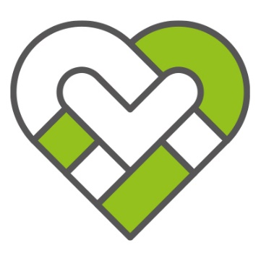
Public and community services, it’s what we all do together

Across Aotearoa in hospitals, libraries, call centers, local and central government offices, homes, national parks and countless other locations public service and community workers keep our country going. This year we get to choose a new government for the next three years and there are very different views from the parties about how they value the work public and community workers do.

We believe its vital to challenge attacks on the work we do and to make protecting public and community services a key debate this election. We would like to hear from you how we can support you to have conversations at work, and with family and friends about the need to stand together to defend the work we do on behalf of all New Zealanders. Scan the QR code to let us know how you will get involved.

Your voice counts.
Public and community workers are strongly supportive of good government and we care about the issues affecting New Zealanders. Our rights and freedoms to participate in the general election are enshrined in law and we will never ask you to compromise the principles of impartiality and professionalism New Zealand’s public service defends and upholds.

We have a short survey we would love for you to complete

Scan the QR code below
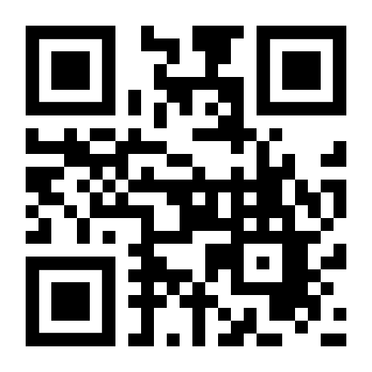

Or fill out the attached paper version

