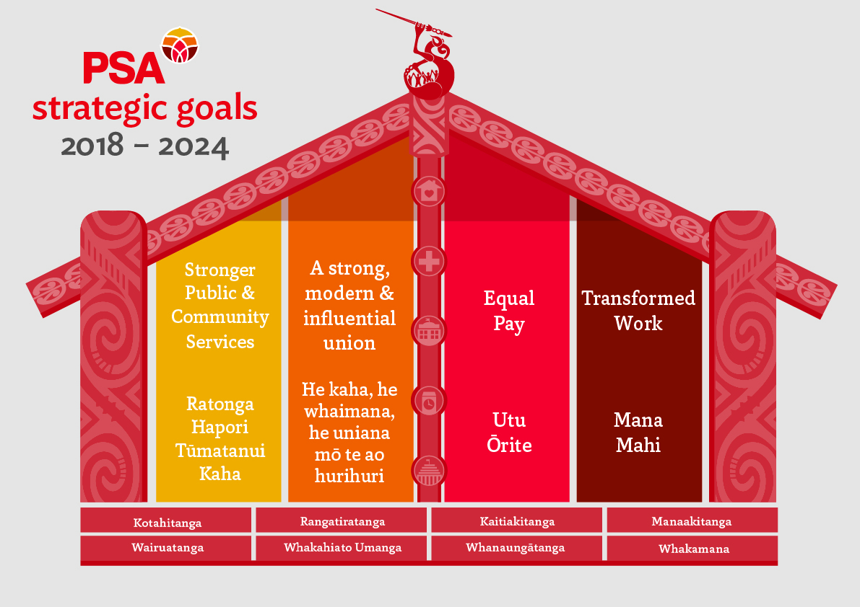
Public Service Sector - AMM Report 2022
Transformed Work, Mana Mahi  Fair and Secure – Kaitiakitanga  Collective Negotiations – We are negotiating this year for around 14,500 members in the Public Service sector including: Oranga Tamariki where bargaining continues, front line Corrections Community/Managers), NZDF, MoJ (Frontline/Managers), MSD (Managers), DIA, Ministry of Culture & Heritage, GCSB, IR, MFE, MHUD, Customs, Te Puni Kōkiri, Statistics NZ, ERO,  Sector wide Bargaining goals:  - Removing Performance based Pay  - Pay increases  - Gender Pay Principles/Equal Pay  - Increased coverage for membership including Manager Collectives  - Common Terms and Conditions across the Public Service sector  - Management of change provisions, job security, and redeployments  - Union only benefits and delegate recognition  - Career development  - Ngā Kaupapa - Te Reo me ona tikanga  - Health & Safety (including Worker Participation agreements)  - High Engagement  - Emergency Provisions (including pandemics)  Career Development - Te huarahi kite akonga  - Developing a model for meaningful professional and personal development for all workers that is free from bias.  Healthy and Safe - Manaakitanga  - Working with Public Sector agencies to ensure Worker Participation Agreements are in place and H&S committees are well functioning,  Trust and Effectiveness - Whakamana  - Continuing our work with many agencies and the State Services Commission on a High Engagement model for work design (Department of Conservation, MSD, Oranga Tamariki, MBIE and Corrections)  Standardised Terms and Conditions  Stand Together for one Public Service:  On-going joint work with agencies and PSC developing standard terms and conditions across the Public Service. | A strong, modern, and influential union – He Kaha, he whaimana, he uniana mō te ao hurihuri  Membership of the Public Service Sector has grown significantly in the last 12 months to over 30,300 members (an increase of more than 3000 members).  We have over 1849 Delegates across the Sector. Our target is to have all our Delegates fully trained and recognised at work. We also have 364 Health and Safety Representatives.  We have a good representation of Vā Moana (Pasefika) delegates across the Public Service sector to give specific leadership to their Pasefika members.  We have a robust youth network (PSAY) in the Public Service sector who promote and encourage the participation of youth in the sector.  Stronger Public and Community services - Ratonga Hapori Tūmatanui Kaha  Your delegates have worked with PSA to make both written and oral submissions on several pieces of legislation and reforms in the last 12 months.  Equal Pay – Utu ōrite  - PS Admin/Clerical Equal Pay Lodged (Oct 2019)  - Gender Pay Gap Action plans, joint work with agencies and PSC to close the gender pay gap  - Gender Pay Principles – Guidelines for Public Service Sector Agencies  - Flexible Work by Default, including working from home  - Work together on the Mana Wahine claim  Ngā Kaupapa  Ngā Kaupapa are values that promote unity and strength for Māori members across the PSA. PSA is working with several agencies on their Māori engagement strategies.

