Māori delegate roles for Election

Introduction
The PSA have representative structures for Māori members across all the governance structures, and workplaces. These roles are called rūnanga delegates and Hinonga Māngai Māori delegates.
The PSA would like to focus on elections of rūnanga delegates across all workplaces where there are Māori members.
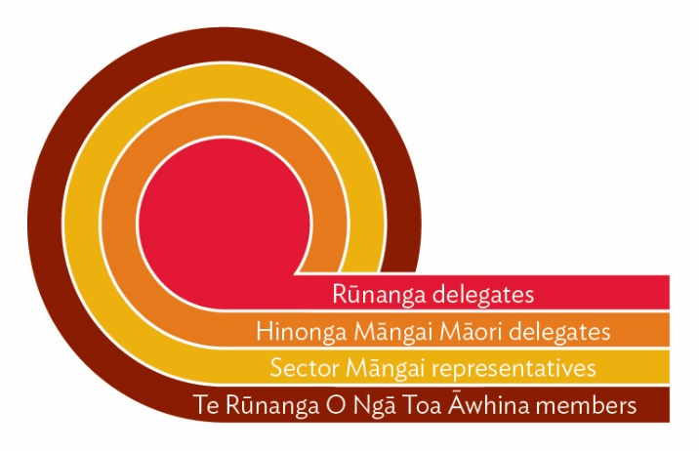
Rūnanga delegate elections mirrors that of workplace delegate elections except, rūnanga delegates are nominated and elected by Māori members ONLY.

Māori delegate structure and General delegate structure

The Māori delegate structure mirrors the general delegate structure elections

Māori members elect Rūnanga delegates and Rūnanga delegate elect a Hinonga Māngai Māori*.

*Except where there are no Rūnanga delegates in a workplace

Do you have a high density of Māori members within your enterprise?
Do you have many workplaces or worksites in an enterprise?
Do you have an enterprise delegate committee?

Advice on election process for Māori delegates/structures

Rūnanga delegate (RD) election Guide

The election process for Rūnanga delegates and Hinonga Māngai Māori delegates do not easily fit into standard voting processes. Accordingly, a process follows, which outlines the election of Rūnanga delegates in the enterprise.

The rūnanga delegate structure for any enterprise relies on the election of Rūnanga Delegates.
Hinonga Māngai Māori Delegate - http://psainfo/organising/resources/maori-resources/

Rūnanga Delegate Definition from the rules;
“A Rūnanga Delegate” means, a Māori member elected by Māori members to be a delegate within the Rūnanga delegate structures in an enterprise where such structures exist. The Rūnanga delegates are workplace delegates with a primary focus on the representation of Māori members on Māori issues in the workplace, and the election of a Hinonga Māngai Māori delegate.” Part 1 (2)1q

Process 1 – Hold election of Rūnanga delegates at the AMM

- Decide on whether you hold the election separate with Māori members only, or with all members
- Agree on the numbers of Rūnanga delegates to represent Māori members
- Call for nominations from the Māori members to be Rūnanga delegates at the AMM
- Call for a vote on the nominated Rūnanga delegates
- Complete Rūnanga delegate nomination form

NOTE: Elections for Rūnanga Delegates mirrors that of the worksite/enterprise delegate elections except that:
- They can ONLY be nominated by Māori Members
- They can ONLY be elected by Māori Members

Where there is high density of Māori members – it may be possible at the AMM in any particular worksite or enterprise to elect for Rūnanga delegates. The call for nominations would be exactly the same as general delegates – taking into account the 2 specific principles above.

Process 2: Where the above is not possible, use the process as follows: (Suggested Wording)

- Agree on the number of Rūnanga delegates to represent Māori members
- Call for nominations from Māori members before the AMM (as part of general notice)
- Talk about role
- Confirm that the election will be held by email (or postal vote) after the AMM
- Generate an email vote through Member Search (with assistance from OA or NOM) – Process below;

Electronic Election of Rūnanga Delegates –

- Identify the Māori Members in each enterprise (Member Search> Employer>Organiser>extended options>ethnicity>Māori>close and save). Will help you locate Māori members in your worksite.
- Email them centrally outlining the role of RD position, and seek nominations from all Māori members.
- Encourage discussion among the Māori delegates in that enterprise and;
- Allow enough time for nomination process as per the rules/regulations (at least 10 days); and

- Where there is more than one nomination, provide an email voting system for them to use if one is required (electronic voting can occur via outlook where possible) – or via email or post
- Once voting is completed, ensure that delegates have completed the new delegates nomination form – Rūnanga delegate, and handed to your OA to be correctly coded in Unison as RD.

- To encourage participation National Organisers should ensure that local organisers are aware that the process is underway.

- Contact – Te Rāngai Kaitakawaenga Māori - for support if required marcia.puru@psa.org.nz

Hinonga Māngai Māori Delegate Elections

Every enterprise delegate committee is to provide a position for a Hinonga Māngai Māori where one is elected. The rūnanga delegates elected are mandated by Māori members to elect a Hinonga Māngai Māori or if no rūnanga structures exist, the Hinonga Māngai Māori will be mandated by Māori members. Māori delegate structures Guide - http://psainfo/organising/resources/maori-resources/

The Hinonga Māngai Māori has a leadership role for Māori members in the enterprise, and are a point of contact with Sector Māngai, Sector Rūnanga and Te Rūnanga o Ngā Toa Āwhina Kōmiti.

Hinonga Māngai Māori Definition from the rules

“Hinonga Māngai Māori” means a Māori member elected by Māori members in an enterprise, to represent the interests of Māori members within that enterprise and to provide a point of connection with
the wider structures of Te Rūnanga o Ngā Toa Āwhina and the PSA. The Hinonga Māngai Māori is a member of the enterprise delegate committee.” Part 1, 2(g)

Process: 3 – Election of Hinonga Māngai Māori Delegates

- Māori Rūnanga delegates once elected should meet to elect a Hinonga Māngai Māori for your enterprise.
- Hinonga Māngai Māori can only be elected by Māori members or Rūnanga delegates where a Rūnanga structure exists.
- There can only be ONE Hinonga Māngai Māori per enterprise elected *
- If there are multiple sites, run an electronic process for the Hinonga Māngai Māori role.
- The rūnanga delegates elected are mandated by Māori members to elect a Hinonga Māngai Māori or if no rūnanga structures exist, the Hinonga Māngai Māori will be mandated by Māori members.

Hinonga Māngai Māori

Elections for Hinonga Māngai Māori can differ depending on the size/nature of the enterprise and whether or not there is a formal Rūnanga structure in place. However, they still must be completed within the general election principles as outlined in the rules.*Tuakana and Teina roles are being implemented across enterprise Rūnanga to support the workload and support needed to fulfil the role and this is being endorsed by the enterprise kōmiti.

Key points:

- Rūnanga delegates elected are mandated by Māori members to elect a Hinonga Māngai Māori or if no rūnanga structures exist, the Hinonga Māngai Māori will be mandated by Māori members.
- Where there is an enterprise with a single site, an election can be undertaken at the AMM, but generally it is easier to run the election separately, using an electronic or postal election process.

- As part of the AMM process organisers/delegates should discuss the Hinonga Māngai Māori delegate with members and let them know that the elections will be held by email or postal vote after the AMMs have been completed.

- All elections must fulfil the principle rule 9 of the PSA rules.

- All Hinonga Māngai Māori to complete a new delegate nomination form – Hinonga Māngai Māori

- Rūnanga delegate structures will vary depending on an enterprise. Please contact: Te Rāngai Kaitakawaenga Māori for support marcia.puru@psa.org.nz

Additional Links

Māori resources – including Ngā kaupapa, http://psainfo/organising/resources/maori-resources/
Rūnanga delegate nomination form - http://psainfo/organising/resources/delegate-support/
Hinonga Māngai Māori nomination form - http://psainfo/organising/resources/delegate-support/

