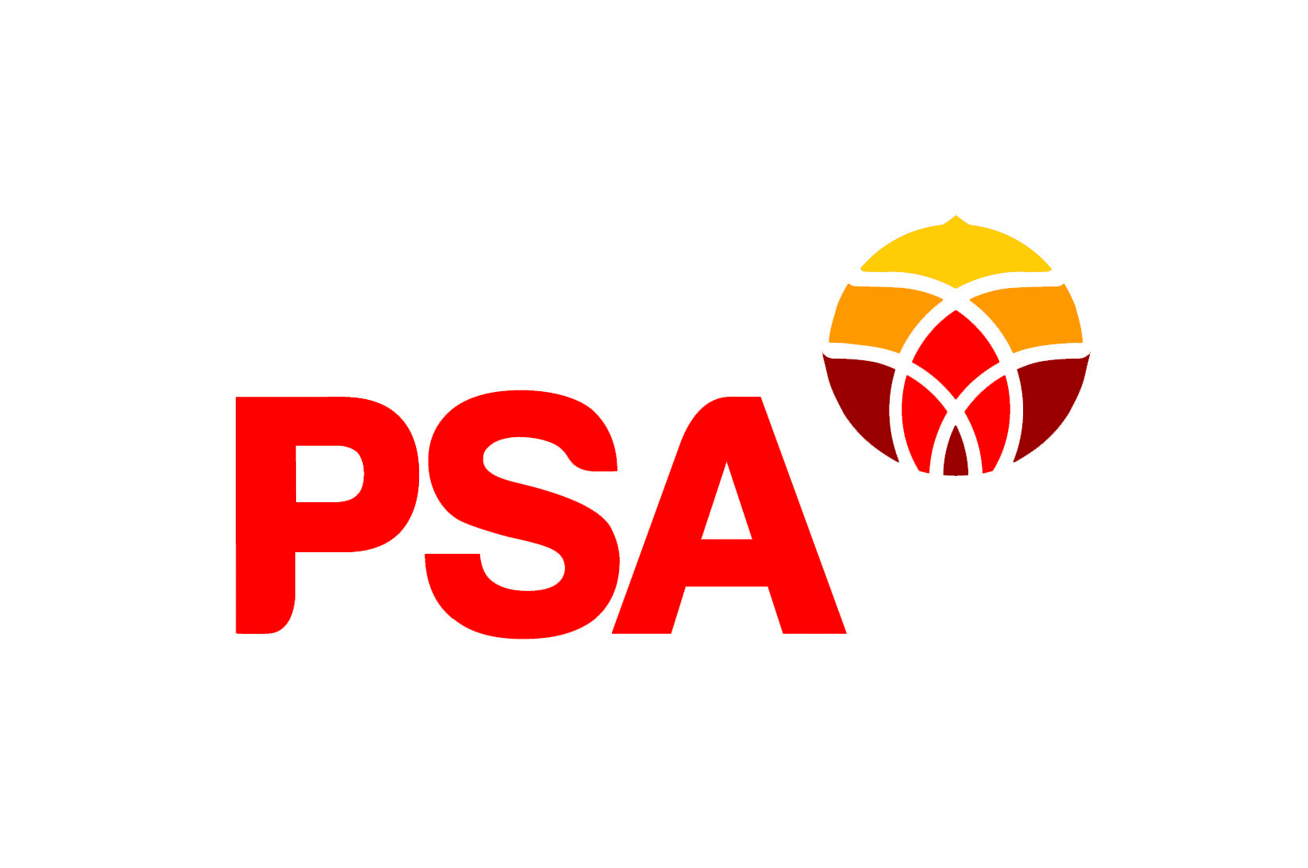

PSA submission to Te Whatu Ora

People & Communications Discussion Document

Introduction

The Public Service Association
The New Zealand Public Service Association Te Pūkenga Here Tikanga Mahi (the PSA) is the largest trade union in New Zealand with over 85,000 members. We are a democratic organisation representing members in the public service, the wider state sector, local government and non-governmental organisations working in the health, social services and community sectors. We have over 25,000 members at Te Whatu Ora.
The PSA believes that maintaining a high functioning, valued and experienced work force provides for a quality service for the people who use the service, which is also a critical factor for stakeholders.

PSA Approach to Restructurings and Reviews
The PSA recognises that change will be necessary to achieve the 5 key system shifts of the health reforms and that change will be a feature of developing and creating Te Whatu Ora. This submission contains constructive and specific recommendations on both the process and substance of the current change proposals.
As a union, the PSA has considerable experience of change proposals and their effects upon staff and service delivery and is not resistant to change. Our focus is on:
- Employment and job security:
  - Maximising opportunities for redeployment, development and training and minimising job losses.

- Worker voice:
  - Ensuring PSA members can have a say in the decisions about whether and what change is needed.
  - Ensuring PSA members can have a say in determining any formal process for implementing any change.

- Fairness and transparency:
  - Ensuring change processes are procedurally fair and transparent.
  - Ensuring decision making processes are transparent.

- Ensuring any change promotes sustainable services, high performing productive workplaces and decent jobs:
  - Mobilising members’ knowledge to improve the efficiency and quality of services and jobs.
  - Once the change has been implemented, monitoring the impact on services and workloads.

Collaborative approach
A collaborative approach to change produces better outcomes and maintains productivity. How change happens and how workers are engaged in the design and delivery of new structures is crucial.
The importance of clear communication around change processes is a core principle for the PSA. This has also repeatedly been upheld by the courts. Goddard CJ adopted the following propositions from a 1993 Court of Appeal judgement (Communication and Energy Workers Union v Telecom NZ Ltd [1993] 2 ERNZ 429) as a guide to employers and employees.

If there is a proposal to make a change, and such change requires to be preceded by consultation, it must not be made until after consultation with those required to be consulted. “They must know what is proposed before they can be expected to give their views.” (see Port Louis Corporation).
This does not involve a right to demand assurances but there must be sufficiently precise information given to enable the person to be consulted to state a view, together with a reasonable opportunity to do so. This may include an opportunity to state views in writing or orally.
The requirement for consultation is never to be treated perfunctorily or as a mere formality. The person or body to be consulted must be given a reasonably ample and sufficient opportunity to express views or to point to problems or difficulties (see Port Louis Corporation).
Consultation must be allowed sufficient time.

This submission
The submission reflects feedback from workers at Te Whatu Ora: delegates, members and non-members.
This submission opens with comments on the process adopted by People and Communications, with a focus on recommendations

Process
Our members appreciated that a different approach was taken to People and Communications in response to the issues raised in early consultations and other change proposals. Some members drew attention to positive experiences locally, or in wider teams.
While our members appreciated that a different approach was taken, they did not feel that communication around that approach had been ideal. They had been expecting a full change document and to learn what was proposed about their jobs, but then received something different. The process of restructuring is very unsettling, which makes clear communication essential.
There are still improvements to be made to the process to make sure that workers have the information that they need and can give effective feedback. If a document has unnecessary information, or repetition, it becomes harder for members to identify the information they need. Clearly written documents that directly speak to members’ circumstances are essential for meaningful consultation. One option would be to create a short summary with key points so that members easily access the most important information.
Members also emphasised the importance of face-to-face meetings as part of consultation. Members want an opportunity to have a conversation with their coworkers about the proposals, rather than just a question and answer format. Access to deep dive and discussion sessions was limited as the “invitation” were via 3rd party and therefore many workers were not provided these opportunities.
In our members’ voices
Nothing related to my role is mentioned in either document, though their purpose is to propose new reporting structures. - The diagram explaining the process provided in one document helped me to understand its structure, but the repetitive, wordy nature of the documents has kept many colleagues from reading them and I feel there's no collaboration in my attempts to understand the process. I'm fairly new here and support has been key to my success, so in my opinion, this is a failure of the process. More concise, less repetitious explainers would be useful for busy staff. I fully understand the urge to write comprehensively, but it's so unhelpful when it prevents people from engaging, which is demonstrably what I see happening here!
We have not been told about any proposals however they will come out in June and will only have short time to respond. This difficult for a rostered shift
I work in emergency management and there has been amazing communication from the Te Whatu Ora emergency management team about the way things work, what's needed, plans for change in this space, etc. We had multiple forums and national and regional meetings about what a new national emergency management team would look like. Full credit to the EM team at Te Whatu Ora for engaging with us so thoroughly. I think I'm disappointed with the People and Communication approach because it contrasts so much with the approach used by the EM team, and also the discussion document barely mentions emergency management so there's no real indication of where things are going to go.
We were expecting a proposed structure to be sent out on the 18/05/23. This hasn't happened. Instead we've been sent a discussion document which has asked us to comment on how People and Communication will function. This is light on detail which makes it hard to give constructive feedback. Additionally, Te Whatu Ora should have indicated much earlier that it wasn't going to be a similar proposal to the previous waves, but instead was going to be delivered in two phases. This would've enabled affected staff to be aware things were being done differently this time around. - - I like that they've obviously listened to feedback about the previous waves and have tried to do something different, but I think they've gone too broad with their approach and they needed to provide more detail for staff that are possibly affected so that they can fairly engage in the process.
The process has had a lack of face-to-face or interactive and deep-dive webinars to discuss the document - a webinar with just Q&A is not a conversation.
Recommendation 1: Clearly communicate the details of timelines and changes in timelines as soon as possible to all workers in People and Communications.
Recommendation 2: Ensure that face to face meetings are held throughout the consultation process and that all workers in People and Communications are aware of these meetings.
Recommendation 3: Create a brief explainer that outlines the key points of the future documents.

Structure
Our members identified the biggest risk in the proposed way of working was the tension between ensuring national consistency and addressing local needs. Members appreciated the possibilities of national systems in terms of consistency, workload and specialised support. They were cautious that local needs would be lost and that a one size fits all approach would not work.
In our members’ voices
[in response to a question about what is good] Reduce duplication of work, potential to nationalise systems. [in response to a question about what needs improvement] Lack of knowledge or consideration for local knowledge and local engagement
[in response to a question about what is good] National consistency - templates, training packages, plans - Increased and specialized support. [in response to a question about what needs improvement] I'm worried a national approach that is too heavy ie one size fits all, won't work and there needs to be a commitment to working locally with national support rather than the other way around.
As a national organisation, it makes sense to have overarching policies for the big picture. If regional policies conflicted, it would cause issues, so creating national 'umbrella' documentation is understandable. This would also save time for the local people who currently upkeep the regional policies. It should be considered a fool's errand to replace ALL regional documentation with nationalised versions, if this is proposed. There are local understandings and possibilities that cannot be coherently translated across 20 regions; the attempt would create less useful documentation, with every specificity is removed - essentially, poorer policy.
Recommendation 4: That the tension between national consistency and meeting local needs is identified as a key challenge that will require ongoing consideration and adjustment from all teams within People and Communications.

Work Location
The other key substantive issue under consultation is the location of work. The document states that all roles will have a home base. There is ambiguity about access to flexible working arrangements. There is a general statement: ‘we’ll still have flexible working arrangements’, but that is not clear whether that ‘we’ refers to the People and Communications team(s) as a whole, or whether individual workers will have access to flexible working arrangements. The following sentence says ‘This means that all roles will, over time, have a “home base” and, where agreed people may have flexible working arrangements’ – implying limited and conditional access to flexible working arrangements.
There was no indication of how this change would be undertaken and how to ensure it was consistent with conditions in CEAs, IEAs, and what has been agreed with individual workers when they started this role.
Our members objected strongly to a limited and conditional access to flexible working arrangements. They value the ability to work from home and other flexible arrangements for a wide variety of reasons. They drew attention to the inadequacy of their current workplaces and the difficulty of working in noisy environments. They discussed the benefits of flexibility of working from home for their team, and concern that they would lose team members.
Over the last few years our members have been required to work from home at short notice in response to a pandemic and disasters such flooding and a cyclone. The employer has expected employees to continue to support teams from home under difficult circumstances and our members have delivered. To turn from the expectation that workers show maximum flexibility to maintain services in a disaster, to limited and conditional access to flexible working arrangements – would create resentment and devalue our members’ work.
Our members drew attention to the wide range of roles and workplace circumstances and want their working arrangements to match their roles. Some members pointed out that their support work was not face to face, but primarily through phone and e-mail and that their roles could and are effectively carried out remotely. Other members understood and supported the requirement to be located in the office some of the time but valued the ability to work from home regularly. What these members had in common was a desire that their workplace arrangements reflected the specific requirements of their role.
A flexible by default would meet both the employer’s desire for roles to have a ‘home base’ and also address workers’ needs for flexibility in a meaningful, rather than limited and conditional, way. Flexibility by default requires treating all roles as flexible unless there is a genuine business reason for a role not to be. That would allow workers in People and Communications teams to identify roles that cannot be worked remotely, but also ensure all workers had access to flexibility.
A flexible by default approach would also ensure that Te Whatu Ora met the expectations of a good employer and promoted equity and inclusion. One of the Pou of Kia Toipoto, the public service pay gaps action plan, is the requirement that ‘By the end of 2024 agencies and entities offer equitable access to flexible-by- default working’. While Te Whatu Ora is pausing its engagement with Kia Toipoto during its set up phase, it should not be moving in the opposite direction to the expectations on Crown agents. Flexibility by default would meet workers’ needs, promote equity and inclusion, and ensure that Te Whatu Ora is well placed to meet the obligations placed on it.
In our members’ voices
Of course we should work from home if it works for the patients and the team! Covid has taught us that!!!!
Working from home has been very effective for us and this is proposed to be reviewed. Payroll does not meet people but to deliver the service through other means such as phone and email. We don't understand of the enforced ideology that everyone must be in office to work and to meet people. Not every role is client facing.
Would be great if I was allowed to work from home. Traffic to get to start work means I live 32 km's from work and need to leave for work at 6.30 for a 8.00 start and on an average finish at 16.30 and arrive home at around 18.00pm . this makes my day to be approx 11 and a half hours long leads to exhaustion
There should be a consideration of what is working well from working from home and preserve this way of working. To get connected, employee can still work in office every now and then to keep in touch with colleagues and for any related purpose.
Really hope PSA can help to represent us to bring a fruitful outcome. Working from home has been a success and would not want this to be taken away please.
The proposed way is going to demotivate us with stress and pressure being put in a one same space to work with noises and unhealthy office environment. The office is not equipped with ventilation and dampness and this creates unhealthy working place. I may lose my colleagues who are based remotely and they are extremely productive workers. - This proposed change is very worrying for us.
There should be more flexibility of ways of working. Why do they want to reduce the WFH even our team is performing well? Why do they want us to stuck in traffic every morning, pay for parking at hospital and always try to find a space for parking?
I think there is cases and cases about this change, but I am not happy about this, as this mean more expenses with gas, parking and food, also 1 to 2 hours of time waste everyday driving from home/work if is not raining, between other thing.
I work flexibly. The proposal suggests that work from home/remote work will not be tolerated. I don't believe it's reasonable to rule out these ways of working, especially for certain roles; it is a gross generalisation to say that support can only be provided in person. What reasons or arguments do you have for the notion that support can only be provided in person?
There needs to be flexibility to allow people to work from home if they choose to do so and allow them to have flexible hours. You do need to balance this with working at the office as well. To be successful in health, you need to build and establish relationships and the work location could affect this. For example, I would expect a health and safety advisor to be at the office most of the time to meet with people and to network, but for some of the time, they could certainly work from home, eg when writing reports.
Recommendation 5: People and Communications embraces flexibility by default as best practice and clearly articulates a flexible by default approach in future discussions of work.

Recommendations
Recommendation 1: Clearly communicate the details of timelines and changes in timelines as soon as possible to all workers in People and Communications.
Recommendation 2: Ensure that face to face meetings are held throughout the consultation process and that all workers in People and Communications are aware of these meetings.
Recommendation 3: Create a brief explainer that outlines the key points of the future documents.
Recommendation 4: That the tension between national consistency and meeting local needs is identified as a key challenge that will require ongoing consideration and adjustment from all teams within People and Communications.
Recommendation 5: People and Communications embraces and practices flexibility by default as best practice.

