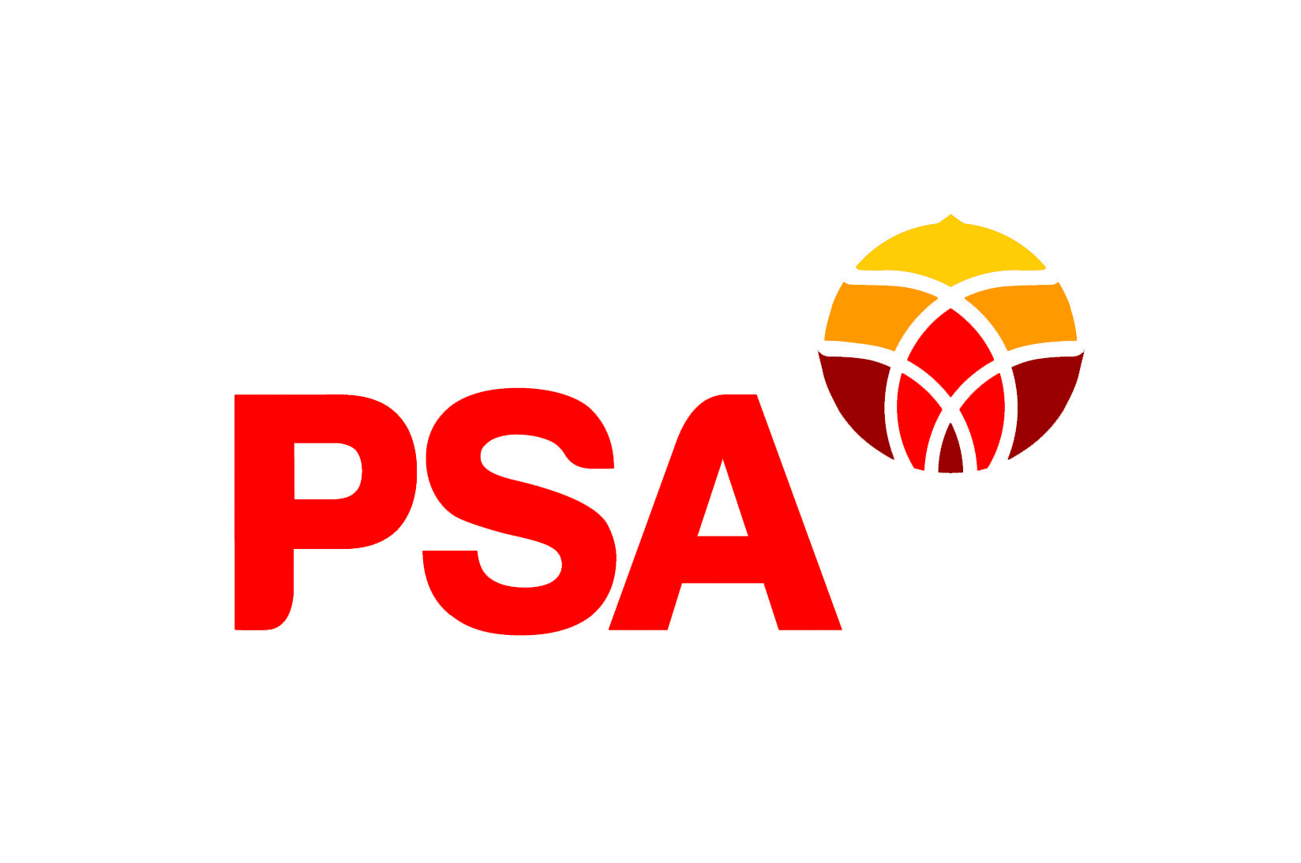

PSA submission to Te Whatu Ora

Proposal for Consultation:

Service Improvement and Innovation

Introduction

The Public Service Association
The New Zealand Public Service Association Te Pūkenga Here Tikanga Mahi (the PSA) is the largest trade union in New Zealand with over 85,000 members. We are a democratic organisation representing members in the public service, the wider state sector, local government and non-governmental organisations working in the health, social services and community sectors. We have over 25,000 members at Te Whatu Ora
The PSA believes that maintaining high functioning, valued and experienced work force provides for a quality service for stakeholders and the clients who use the service.

PSA Approach to Restructurings and Reviews
The PSA recognises that change will be necessary to achieve the 5 key system shifts of the health reforms and that change will be a feature of creating Te Whatu Ora.
As a union, the PSA is not resistant to change and has considerable experience of change proposals and their effects upon staff and service delivery. Our focus is on:
- Employment and job security:
  - Minimising job losses and maximising opportunities for redeployment, development and training.

- Worker voice:
  - Ensuring PSA members can have a say in the decisions about whether and what change is needed;
  - Ensuring PSA members can have a say in determining any formal process for implementing any change.

- Fairness and transparency:
  - Ensuring change processes are procedurally fair and transparent.
  - Ensuring decision making processes are transparent.

- Ensuring any change promotes sustainable services, high performing productive workplaces and decent jobs:
  - Mobilising members’ knowledge to improve the efficiency and quality of services and jobs.
  - Once the change has been implemented, monitoring the impact on workloads and services.

A collaborative approach to change produces better outcomes and maintains productivity. How change happens and how workers are engaged in design and delivery of new structures is crucial.
The importance of clear communication around change processes is a core principle for the PSA, it has also repeatedly been upheld by the courts. Goddard CJ adopted the following propositions from a 1993 Court of Appeal judgement (Communication and Energy Workers Union v Telecom NZ Ltd [1993] 2 ERNZ 429) as a guide to employers and employees.

If there is a proposal to make a change, and such change requires to be preceded by consultation, it must not be made until after consultation with those required to be consulted. They must know what is proposed before they can be expected to give their views’ (see Port Louis Corporation).
This does not involve a right to demand assurances but there must be sufficiently precise information given to enable the person to be consulted to state a view together with a reasonable opportunity to do so. This may include an opportunity to state views in writing or orally.
The requirement for consultation is never to be treated perfunctorily or as a mere formality. The person or body to be consulted must be given a reasonably ample and sufficient opportunity to express views or to point to problems or difficulties (see Port Louis Corporation).
Consultation must be allowed sufficient time.

This submission
The submission reflects feedback from workers at Te Whatu Ora: delegates, members and non-members. Two surveys were carried out, one entirely qualitative and one qualitative and quantative.
The focus of this submission is the process of restructuring as a whole, with additional comments on the implication for Service Improvement and Innovation. In addition, we have provided feedback on the proposal itself. Our members ability to give feedback has been limited by the lack of information about what is proposed, so the focus is on raising issues that our members need to see addressed.

Our members support the health reforms
Our members have always been very supportive of the goals of the health reforms and embraced the benefits a unified health system could bring. Our submissions to the Pae Ora Healthy Futures Bill were enthusiastic and our members welcomed the formation of Te Whatu Ora and Te Aka Whai Ora.
As long as it's tika and pono and enables us to expand into areas that have never been accessible to our kaimahi before, change is something I'm all for if it means improving our services.
Our members still see the value of the changes that were promised. Our members were most positive when they were speaking about the possibilities of reforms and the changes that they wanted to see:
I hope that systems/areas from the old DHBs be streamlined so that we are all working from the same systems
Hopefully a focus will be on more equitable care, and less duplication of roles.
Hopefully it will help with transfer of staff through the hospitals and repeated information / training for them, repetitive training done once.
This submission will outline the very negative experiences our members have had with the restructuring process. We emphasise that this negativity comes as a result of the experiences people who supported the goals of the reforms have had within Te Whatu Ora and of these reforms. The mismatch between support for the goals of the reforms and negative experiences of the process shows the imperative of Te Whatu Ora taking this feedback seriously and amending their practices.

The Consultation Process

Our members don’t have the information they need
The information is too vague to make an informed comment.
I don't know what's going on and I'm afraid I'll lose my job.
The most overwhelming response from our members was that they did not understand the change proposal and did not know what impact it would have on their work. The two comments quoted above were repeated over and over again, as members were very clear that neither the information, nor the way it was presented were clear. Just 16 per cent of those who responded to our survey said that they felt they had a good understanding of the proposal.

Our members were very clear that the proposals had not been effectively communicated to them. They mentioned specifically mentioned the language of the document and the approach of all staff hui as obstacles.
I feel like my manager hasn't had enough information at any point during this process to support me well. She's been very in the dark, which I don't think is her fault. - - There has been a massive quality of information to take in, which has a lot of jargon in it. This has meant it has taken considerable time and effort to understand the proposal.
Members mentioned that the approach of all staff hui further suggested that management did not understand the current state.
They have held hui to discuss changes but I have been unable to attend or watch any of these during work hours. We cannot watch the recordings either because we don’t have a computer operating system that can play them and also have no sound on work computers (and also no time to watch them). They need to distribute a written summary of the changes and what the implications are for each department , and allow adequate time for feedback
Our members have not been communicated to well about what had been proposed. Communication about what it had meant for them. Just 7% of members agreed that they understood what it meant for them personally.

Members described questions not being answered and lack of clarity in communication.
The more consultation I have, the more confused I am about where my role and that of my counterparts across the region will fit
We have no idea what is going on in our department in regards to proposed line change as no one got back to us after we gave feedback. We are left in limbo.

Te Whatu Ora’s approach to consultation
The confusion members described is not coincidental, but a result of a series of decisions that Te What Ora has made about its approach to restructuring. This round of consultation and restructuring are to the top 5 tiers of leadership only. Our members pointed out again and again that work had not been done to consider and communicate the implications for the rest of the organisation.
They've worked from a top down approach and haven't considered the bottom up.
It seems the restructure is effecting upper and middle management at the moment. There's no discussion about the impact this will have at a grass roots level.
The decision to restructure from the top down is defensible (although some members strongly criticised it), but the decision to present those decisions without full consideration of the rest of the organisation is not. As one member put it: “We have been asked to give feedback on something that we can't see ourselves in.”

Lack of information of current state
Members repeatedly made clear that the proposals did not show a good understanding of their work or the current state. They emphasised that without a good understanding of the current state it was impossible to understand how to undertake reform.
The proposed restructure is being done to us rather than with us. We have been restructured by people who do not understand the capacity and capability required to deliver on the mahi. There should have been more conversations with teams and senior leaders within teams to understand what is needed. This still needs to happen.
It is the worst I have seen in the last 20 years, and I've seen dozens. Head Office have no idea of my role, and when I contribute to papers that are apparently to help them understand they seem to be incapable of understanding. Real time decisions are being made without understanding the system.
There should be a face to face visit to understand what some roles are about. Centrally created structure is too idealistic , there are many jobs in the background that will not be done under the new structure, there will be nobody to do them.
The lack of knowledge about the current state significantly damaged the process of consultation. Consultation documents went out with errors and members were unable to discover if they were affected and how.
I spent an exceptionally long time not receiving any communications and being told that 'no communications meant my job wouldn't change' - until I saw that I had no place in the future state. The reason provided to me was that I started 7/2/23 - but it's a trivial activity to get a list of new starters and communicate with them directly to let them know their communications would be delayed.
This has been overlooked and I can not see a role that will pick up that responsibility.
No time to look at how this effect me, as my role isn't actually correctly mapped correctly in here.
It is impossible to design a new system or consult on changes without a full picture of the existing state of the organisation.

Impact on members
Our members outlined that this lack of consideration for them and the work that they do in the consultation documents had an impact on them. Te Whatu Ora is communicating about its values in terms of who it considers as part of change and how it communicates that change, and our members are receiving the message loud and clear.
It was disrespectful not to engage with the managers and their teams about the work they do prior to designing the new structure. So much of what we do is not represented in the new structure. Is this their way of saying that what we do doesn't matter and is therefore not worth continuing? That's what it feels like anyway!
The leadership group's lack of empathy in addressing the restructuring process is troubling, and at times, difficult to comprehend. It is particularly concerning when a leader dismisses the situation, despite the evident and meaningful impact on our team. –

Additional issues with restructuring
In addition, to the big picture issues with the process already discussed, our members raised a number of other issues with the process of restructuring.

Approach to allocating staff to new roles
Our members expressed concern with the approach to allocating staff to new roles was damaged by the lack of information about the current state outlined above.
They should have sought clarity around what actual duties people with job titles did as it is no use then coming back with this so called further consultation ...to possibly still employ the people with a different job title. The angst and stress that this process is causing is huge and shows a very real lack of care and integrity. - The fact that people cannot apply for 'new' roles until they have been disestablished is inappropriate shocking
The process was not designed with workers needs in mind – nor to minimise job losses and maximise job security.
My concern is that those in the later waves of consultations might miss out on new job opportunities in the earlier waves. - - I have non-clinical skills that are not tied to a particular function so if I am disestablished, I could have applied for roles in the earlier waves of consultations. - - I understand that it would be difficult to change the whole organisation in a single wave but I'm not sure they are acting in good faith with those in the later waves

Equity
Our members raised equity issues with the process, which demonstrated that the process had not engaged with workers whole selves.
Cultural competency and safety - -Re the process, cultural competency has been completely overlooked. There should have been kaumatua at each feedback meeting to look after cultural protocols including karakia.
Employees with accessibility needs and/or being neurodivergent would be heavily impacted by this kind of change but it does not seem to be enough level of specific considerations and supports.

Timeframe
Our members were very clear that the timeframe for the consultation was inadequate.
Time frame for consultation included school holidays and public holidays and many people taking leave at different times made it hard to meet and discuss changes and prepare responses collectively.

Format for feedback
Members expressed concern about the limited options for expressing feedback and in particular the limited option for collective feedback.
There should be options to put in written feedback, recorded verbal feedback, one to one meetings, meetings as a small team, meetings at different levels (eg senior leadership, advisor level, programme management level etc). We need to have the opportunity to feedback verbally either one-to-one, and as smaller team as well as with larger teams. There should also be an opportunity to provide detailed reports to the consultation team.
Members also expressed concerns about the on-line consultation tool. No ability to upload documents/diagrams. The fact that they had to set up a login made people very sceptical that it was anonymous. Members articulated a fear that individuals who spoke out would be targeted:
People are frightened to provide comment or ask questions in case they are targeted and disestablished.

Impact on Workers
A restructuring process that is badly run comes at a cost. Our members outlined the impact that the process had had on them, their teams and their work.
The recent restructuring has had a profound impact on our teams' effectiveness, significantly undermining the resilience and cohesion we developed as a team in response to the challenges of the COVID-19 pandemic etc.
This process has left me feeling very undervalued and makes me wonder if I really want to work for an organisation that treats their staff in such a manner
Te Whatu Ora can ill afford to pay the cost of losing workers and less resilient teams.
As well as an institutional cost, this approach to restructuring has had a personal cost. Our members articulated again and again the impact that the change process had had on them and their colleagues:
They way I found out I was impacted was second hand by a colleague in another region who received their email 12 hours ahead of mine. I feel totally disrespected and traumatised.
Increased levels of anxiety and uncertainty ripple through all staff. Does not feel like a transparent process.
This process has left me feeling very undervalued and makes me wonder if I really want to work for an organisation that treats their staff in such a manner
Do you understand that by lifting and shifting people with no clear understanding of their roles you are creating huge stress and distress. It is not good enough to keep saying sorry

Service Improvement and Innovation specific process concerns
Members in Service Improvement and Innovation raised the same concerns that have already been outlined. They emphasised that the document did not show any knowledge of what they already do.
This experience, described by a member who works in Service Improvement and Innovation, demonstrates the casual cruelty of the badly designed consultation process:
My Manager was kept out of the loop, therefore couldn't talk to Manager as they were none the wiser initially. The information Te Whatu Ora had about our team was incorrect, so they consulted with only half the team. The zoom announcement meeting was useless, as couldn't tell who was who in the panel, HR connected us late to the meeting so we missed introductions and couldn't read the slides as the writing was far too small.
Another member asked for face to face visits to ensure that the proposals understand what work is being done.
There were also specific concerns about the timing of the proposals and ensuring that members had maximum opportunity to apply for other roles. Ensuring that the recruitment process for new roles is designed to maximise job opportunities and job security will be essential.
In members voices:
I feel like my role will be affected later, and there won’t be anything similar left in our Improvement group that I could do. The other most closely aligned group Data & Digital’s proposal is out now, so I’m not sure if I should be applying for one of those roles? Hard when they are all proposed at different times.

Feedback on the proposal
Our members welcomed the following aspects of the proposal:
- The establishment of a structure that provides voice for Asian communities
- The proposal recognised the value of the role Business Intelligence Analyst

Our members ability to give concrete feedback on the proposal was hampered by the lack of information. The only information of substance in this proposal were an organisation chart of leadership roles and list of disestablished positions and organizational changes. This left our members guessing at the impact the restructuring and change in reporting lines would have on them. Most of the specific feedback members provided was asking for further information, or expressing concerns that the practicalities about how systems would work had not been considered.

These proposals contain no discussion of transition or ensuring that the support people need continue to be provided. This must be treated as a matter of urgency.
The key challenge for this restructure was articulated by one of our members:
I would like to have a clearer picture on how national management works with the regional and local branches, and the front line workers.
The current consultation document do not address this, and it is imperative that the practical work of understanding how these different levels of organisation work together is undertaken, before positions are disestablished.

Consumer voice
Our members emphasised the importance of consumer voice and saw benefit to roles being shared nationally. They thought it was important that There was question about its placement in Service Improvement and Innovation. Our members proposed careful thinking about the functions involved and where they sat. Members felt very strongly about ensuring that these functions worked
In members voices
there is the Complaints/Feedback part which I believe belongs in Quality & Patient Safety, and then there is the Consumer Groups/Code of Expectation/Co-Design part that belongs in Consumer & Whanau Voice
There's a fear that these roles will become tokenism and not serve our communities appropriately. What can we do to prevent this tokenism from happening? There needs to be demonstrable outcomes listed with the roles/titles.

Clinical Trials
Our members expressed concern about the transfer of clinical trial staff and functions from local to regional and national. Clinical trials are often part of international projects and the international organisations need contact with the local researchers who are doing the work. Full consideration of the practical and logistical elements of how the new structure will work is necessary before going forward.
In members voices
There is little actual detail available on how the new Te Whatu Ora plan would work but would all approvals, including legal, research and financial (hence contracts, budgets etc ie risk management), have to be devolved to some regional or national office? Or would it have to be passed around and across multiple parts of the new organisation for sign off (which could seriously delay study start times) for approval? Who would sign off on this and how would this work?

Wider Impact
Members who were not directly affected by the Service Improvement and Innovation changes expressed concern at losing essential local support systems. They consider it vital that proper transition arrangements are developed in consultation with internal users of services.

In members voices
We're losing our support systems - For example, our Wellbeing Team, Project Leads and Ko Awatea education support. These roles have been prematurely disestablished - they're people we've built working relationships with (especially over Covid) & work in these areas that is half complete. Not everything can be achieved at a national level -different hospitals with different demographic populations have different needs. We should have some support to complete these projects.

What would a better process look like?
Te Whatu Ora does not need to reinvent the wheel, or be innovative in its approach to change processes (although it would be appropriate for Te Whatu Ora to be an exemplar when it comes to meaningful actions to promote workers wellbeing through a change process). Te Whatu Ora needs to follow well established principles to engage with workers in a meaningful way.
One of the more optimistic comments from our members outlines the choice Te Whatu Ora has now:
I think it's necessary to restructure in order to create better collaboration and efficiencies. Change is uncomfortable but is a reality of life. Te Whatu Ora understandably cannot provide detail about where lower tiers will sit until they sort out the upper levels, so a lot of us don't really quite know where we will stand in the long run. I think Te Whatu Ora have been honest and transparent. Time will tell whether they genuinely listen to feedback from staff.

Recommendations

This change process
Te Whatu Ora can restore trust with workers by genuinely listening to feedback from staff about the damage the process has done and take the following actions:
- Consider, engage with and publicly respond to the issues raised with the current process
- Redesign the approach for the appointment to roles, in consultation of unions, in a way that minimises job losses and maximises job security.
- Acknowledge that these changes have been made without good information and feedback from workers about the impact and accept and respond to further feedback, in whatever form.

Future waves
I am about to be restructured as I am in the next wave and it is increasingly stressful.
There are more waves of change proposals in this process, and many more change proposals in order to realise the 5 key system shifts that Te Whatu Ora was formed to achieve. These change proposals are of such a magnitude they would benefit from having a SHEF Change Management Framework (CMF) sub-committee.
- Prioritise and resource obtaining good information about the current state, before releasing any more
- Prioritise and resource considerations of how proposals will impact on those in non-leadership before release
- Ensure all communication provides full information about the impact of changes on staff in a format that is accessible
- Accept feedback in a range of forms. Prioritise ensuring people can give face to face feedback and collective feedback.
- Amend the process to address the equity issues raised
- Provide adequate time for serious consideration and response

