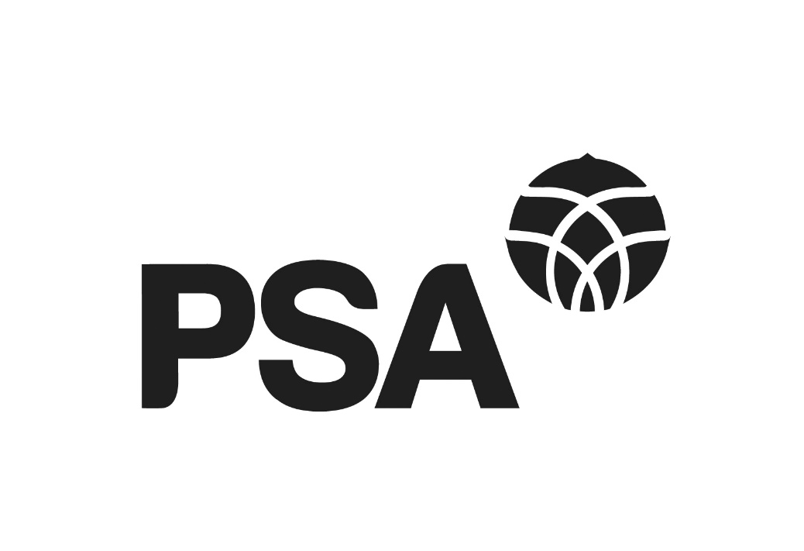
PSA Submission on the Accessibility for New Zealanders Bill
to the Social Services and Community Committee

7 November 2022

PSA Submission on the Accessibility for New Zealanders Bill

About the PSA
The New Zealand Public Service Association Te Pūkenga Here Tikanga Mahi (the PSA) is the largest trade union in New Zealand with over 81,000 members. We are a democratic and bicultural organisation representing people working in the Public Service including for departments, Crown agents and other crown entities including Te Whatu Ora, and state-owned enterprises; local authorities; tertiary education institutions; and non-governmental organisations working in the health, social services and community sectors.

The PSA Deaf and Disabled Network is the PSA structure representing members who identify as Deaf or disabled. The Network has 1,200 members and its purpose is to promote the interests of Deaf and disabled people within the PSA, facilitate the sharing of information and experiences, encourage and support Deaf and disabled peoples’ participation in the representative structures at all levels.

We are committed to advancing the Tiriti o Waitangi through our work. Te Rūnanga o Ngā Toa Āwhina is the Māori arm of the PSA membership. The PSA is affiliated to Te Kauae Kaimahi the New Zealand Council of Trade Unions, Public Services International and UniGlobal.

This submission
This submission was developed with the PSA Deaf and Disabled Network Committee. In preparing this submission we sought feedback from members of the PSA Deaf and Disabled Network through a survey. Their views informed and are an integral part of this submission. Please note that indented text is quotes by PSA members.

Summary
The PSA supports the need for legislation that advances accessibility as a right. The PSA does not support the Accessibility for New Zealanders Bill in its current form, because it does not provide for, or offer a pathway to, a more accessible society.

This submission sets out our members’ comments on the need for accessibility legislation and what legislation should look like. It then sets out the limitations of the current legislation and uses members experience at work as evidence that committees and plans are not adequate to advance accessibility.

Then this submission sets out key aspects of effective accessibility legislation. Those key aspects are that it is codesigned with Tāngata Whaikaha, disabled people and their organisations and that it provides for enforceable accessibility rights through:
- Minimum standards of accessibility
- Timeframes to improve accessibility
- The ability to investigate accessibility breaches

The PSA recommend that the Select Committee amend and strengthen the Bill to provide a right to accessibility, embed the principle of codesign, and give the Accessibility Committee powers to enforce the right to accessibility including: the ability to investigate accessibility breaches, set timeframes to improve accessibility and set minimum standards for accessibility.

Accessibility legislation is needed
The PSA supports legislation that advances accessibility as a right and that sets out appropriate powers and structures to ensure that right is realised. Accessibility is a core right under the United Nations Convention on the Rights of Persons with Disabilities (UNCRPD) and in New Zealand that right is not currently realised.

Deaf and Disabled Network members’ comments on the need for accessibility legislation and what legislation should look like:
Disabled people will be able to fully participate in all areas of daily life including living in an accessible home environment, Community and public buildings including public toilet facilities, hotel and motel accommodation, access to public transport, information, public health services, roading and curbs, car parking. Social Media. Employment, schools. Everything.

If your brain or body is different to the majority you should still be able to participate actively in all of society. Services, workplaces, homes and community spaces should be designed to be accessible to everyone. Accessibility is not just about physical space; it includes the way that services, work, houses and recreation spaces are structured, distributed and valued.

Equal access and opportunities would significantly improve quality of life and ability to FULLY participate in everyday life. It would eliminate barriers to participation and create a more inclusive society.

Something that will enable persons previously held back, to be able to have access for whatever reasons. People should be able to have access to things they require to enable a better quality of life for all not just some.

Accessibility legislation would provide the same access and respect non disabled people receive

Something with teeth and is meaningful. It needs to be something that makes my life easier and better.

Accessibility law describes what to do to ensure that wherever practicable, humans can participate in and enjoy ordinary activities.

A law that requires enforcement of accessibility in the workplace, especially when that workplace is a government building. A law that actively provides a structure for disabled people to demand equal access to their work and their daily life needs without feeling burdensome.

Accessibility legislation to include and consider the needs of those with invisible disabilities and permanent medical conditions

Anyone no matter ability or disability has access to everything.

To allow equal accessibility for all people deaf and disabilities Commercial, Residential and community access for example: Stair lifts, ramps, more car parking, toilets made larger. Shops with wider isles for wheel chairs.

No discrimination in the workplace due to disabilities of any kind.

Accessibility to be a mandatory consideration in construction and design so that it’s a starting point in all builds and renovations and in the provision of public areas like cafes and sports grounds.

Accessibility legislation needs to be based on the UN Convention on the Rights of Persons with Disabilities.

Accessibility legislation would give me greater access to media and information and cultural life and wellbeing.

That ALL who are deaf and disabled have the same rights as someone who is not deaf or disabled. That we do not have to jump through hoops to get the resources we need to help us do our job.

Deaf and Disabled network members currently face accessibility barriers at work. Many members stated that they would be able to work more hours, or have a better range of options with employment, or work security, if New Zealand had strong accessibility legislation.

One member outlined what they wanted from accessibility legislation: “Access to the community, access to information, access to same opportunities of those who are not disabled. Physical access as well as being able to enforce public spaces to be accessible by certain dates.” Then they replied to a question about what it would mean if this legislation was in place they stated: “Being able to work full time.”

Deaf and Disabled Network members’ comments on the relationship between inaccessibility and work
Accessibility legislation may provide better financial or job security for myself. Enabling me to work with dignity using reasonable accommodations to ensure I’m working within the limits of my condition and not to simply meet able bodied expectations/demands of the workplace.

Autistics are disabled by worksite rules and policies. We need less light and quieter areas to work or access to noise cancelling headphones. This isn’t optional or nice to have. Without these things, autistic breakdown is inevitable and it is awful. Jobs are lost, people are homeless and suicide is common.

Limitations of Accessibility for New Zealanders Bill
There is an urgent need to address the barriers Deaf and disabled people face to equal participation in society. The legislation before the select committee does not have the power to address these barriers. The current bill does not provide for, or offer a pathway to, accessibility as an enforceable right, the ability to investigate accessibility breaches, timeframes to improve accessibility, or minimum standards of accessibility. These features are all necessary features of meaningful accessibility legislation.

The current legislation that provides no mechanisms to make New Zealand more accessible and has no powers, risks further entrenching the ways in which disabled people are excluded from society. As one member said: “Because fundamentally no matter what I contribute to this world, I will always be seen as a burden because I am disabled. This proposed legislation just makes that even more apparent, and it tells me that this government considers me as less than human.”

The PSA supports the need for accessibility legislation and that is why the PSA cannot support the Accessibility for New Zealanders Bill in its current form.

The fundamental problem of the Accessibility for New Zealanders Bill is that it sets up new committees without any powers. PSA members’ experiences of discrimination and barriers in employment demonstrates that committees and work programmes have not succeeded in making New Zealand more accessible. New Zealand has Disability Strategy and Disability Action Plan, both of which emphasise the importance of accessibility and work for disabled people. In addition, an initial outcome in the Disability Employment Action Plan ‘Working Matters’ is that the Public Service leads by example with inclusive and wellbeing enhancing workplaces. Despite these plans and undertakings, our members are still facing discrimination and barriers in their employment with no clear path of recourse.

If plans and committees were adequate to ensure workplace accessibility, then Deaf and Disabled PSA members would have vastly different workplace experiences. The barriers Deaf and Disabled Members face at work demonstrates the importance for legislation that provides an enforceable right to accessibility.

Deaf and Disabled Network members’ comments on barriers and discrimination they face at work
My workplace has the speakers disabled on all of its computers, I read using a read aloud tool. The IT team deemed it too hard to fix. Embarrassed and alone I found a computer enabled on a meetings laptop on a separate floor of the building. For me, accessibility is a 2 minute walk away, everyday. It makes me feel like I don’t matter, that I am just being ‘difficult’.

My friends, family and peers are required to fill in the gaps left behind that workplaces should be able to accommodate. I should not have to spend excessive amounts of money just to make sure I can work, only to have to work less than others because I cannot sustain a full work week.

Because I am not visibly disabled, my needs are often dismissed, and the risk of souring working relationships means I often “grin and bear” situations like noisy, crowded environments which cause distress and impact productivity. Another example: I benefit enormously from closed captioning, however it is exhausting to have to keep asking for it. I hope an accessibility law would improve workplace conditions enough that I could focus more of my energy on actually working.

At the moment, the barrier that most concerns me is something a minor as heavy doors as my shoulder power decreases.

Using the bathroom on the floor I work in requires me to get out of my wheelchair to enter the bathroom, luckily, I am able to do this safely others would not be as lucky. Otherwise, I would need to go through two sets of security doors up a floor in a lift in order to go.

My team have daily stand up & I’m excluded from reporting on my workload for the day. Several times I’ve been asked to book interpreter at short notice & this means I miss out on information at team meetings when an interpreter is not available. Workbridge funding covers the interpreter costs which I manage, but when this runs out, I’m expected to cover the cost instead of my employer. I have worked for [entity] for over 19 years and have had no opportunity offered to me for personal development to enable me to grow & progress within the organisation. I would like to be treated fairly and the same as my colleagues.

The Select Committee should amend the legislation so that it provides an enforceable right to accessibility, which would help deliver on a more equal Aotearoa. A member of the Deaf and Disabled Network expressed what they were seeking from this legislation: “For people with disabilities in New Zealand to accept as a given that their lives will equate as near as possible, to those of every other citizen.”

Key Features of Meaningful Accessibility Legislation
Meaningful accessibility legislation needs to enshrine an enforceable right to accessibility. At the moment, Deaf and disabled people do not have an enforceable right that enables them to access public spaces, services, workplaces and all areas of society. PSA Deaf and Disabled Network Members described encountering barriers in all areas of public life: public transport, the built environment, access to information, workplaces, leisure, and housing. New Zealand’s currently approach to accessibility is clearly inadequate and substantial legislative change is needed.

Deaf and Disabled Network members’ comments on the importance and impact of an enforceable right to accessibility

Accessibility Legislation would give me greater employment opportunities in that I wouldn’t need to ascertain if I can actually get into a building before I consider trying to obtain a job in there. I would be able to join in more varied club and social gatherings instead of having to frequent the same buildings that are accessible.

I find walking difficult and have balance issues. Having accessible public transport and decent footpaths with no blockages would help enormously. Rails and handholds would be an enormous help on ramps. I have experienced discrimination in private workplaces mostly due to premises being designed for the abled only. With no incentive for owners to have to bring their buildings up to modern codes. I have had to limit my career to roles in government departments where there is more accommodation of the needs of disabled people.

Taxis are increasingly difficult to enter and exit from as are some buses. These forms of transport need to accessible for all.

An enforceable right to accessibility would provide access to websites and information generally, access to television through increased audio description, better functionality of IT programmes for work.

As well as setting out an enforceable right to accessibility, Accessibility legislation needs to sets out appropriate powers and structures to ensure that right is realised. The key aspects of effective accessibility legislation are that it is codesigned with Tāngata Whaikaha, disabled people and their organisations and that it provides for enforceable accessibility rights through:
- Minimum standards of accessibility
- Timeframes to improve accessibility
- The ability to investigate accessibility breaches

New Zealand is currently a very long way from being an accessible society. Legislation that set out minimum standards, timeframes, and the ability to investigate breaches would provide a process to make New Zealand more accessible. Minimum standards would make accessibility easier for all involved as organisations would know what they needed to do to ensure accessibility, and Deaf and disabled people would be able to navigate the world with certainty about what was accessible. At the moment, organisations can claim that they are accessible, while there are significant barriers to access.

Deaf and Disabled Network members’ comments on the importance of minimum standards, timeframes and impact of an enforceable right to accessibility

When I think “accessibility law” I think clear, minimum standards and expectations on organisations etc in relation to accessibility in Aotearoa, clear outcomes if they breach these standards and expectations, clear definitions on accessibility representatives (similar to Health and Safety reps) and the roles that each party needs to fulfil, a clear purpose for the accessibility laws etc.

Access for All laws regarding building, toilet and parking to be mandatory to all new builds and actions made to existing buildings in order to be accessible. Accessibility law needs to be enforced and unlawful facilities to be investigated.

A process where accessibility standards for most areas of society are developed, reviewed, updated and enforced.

Deaf and Disabled Network members’ comments on the impact on their life of the lack of minimum standards for accessibility or a pathway to investigate breaches

Accessibility Legislation improve my work life by alot as I find that alot of places say they are Accessible, but are not. They have steps.

In my personal life, I am consistently having to plan ahead to ensure unfamiliar places are accessible in order to have my decision made for me whether to attend or participate in certain activities. One example was an outside of work event in which I called the place to check whether their facilities were accessible and was told ‘Absolutely’. The table was situated on ground level for easier access to accommodate a wheelchair however during the evening I needed to use the toilet and could not get in the door. It resulted in me having to push to a next door facility in order to just go to the toilet which is a life necessity.

My workplace has not met accessibility needs for months due to a broken entrance. The basic upgrades I have asked for to the building to actually make it more accessible to me as a wheelchair user (power opening doors) would also provide an increase of accessibility for all users in emergency - this was outright denied because a new building is coming in the future and we can just wait for that.

The PSA supports the principles of co-design and ‘nothing about us without us’. The right of disabled people and their organisations to be involved in the development and implementation of legislation and policies is protected under article 4(3) of the UNCRPD. Members of the Deaf and disabled Networks have to be experts in accessibility in order to be able to navigate a disabling world. It is important that this expertise is recognised in Accessibility legislation and that the system is co-designed.

Deaf and Disabled Network members’ comments on the importance of codesign
Legislation should provide a codified requirement that people with lived in experience as a part of/alongside members of NZ’s differently abled community be consulted and invited to take part in governance decisions that will/could impact on our communities lives.

In my current role I am both employee and expert - I have had to make presentations, bring excessive amounts of learning materials, and find tools that are “acceptable” in my workplace, just to be able to work part time. Despite the fact that my conditions are chronic/permanent I have to constantly advocate for myself over and over again for things that are simply not going to change. I have to provide answers that simple do not exist, because all other solutions I’ve presented have not fit expectations that are frankly, pointless. Having my integrity constantly under question when I am working my hardest, simply because my body does not function the same as others, is tiring.

Recommendations
The PSA recommend that the Select Committee amend and strengthen the Bill to provide a right to accessibility and give the Accessibility Committee powers to enforce that right. The crucial elements of meaningful legislation are that it is codesigned with Tāngata Whaikaha, disabled people and their organisations and that it provides for enforceable accessibility rights through:
- Minimum standards of accessibility
- Timeframes to improve accessibility
- The ability to investigate accessibility breaches

We would like to end the submission with a final comment from one of our members:

I love my job, I love my home, but I am not having my basic needs met. The sidewalks are not wheelchair friendly, the cities are not accessible, and do not even get me started on rural New Zealand. We can fix this, and You Really Should.

For further information about this submission, please contact:
Grace Millar
Advisor, policy and strategy

New Zealand Public Service Association
PO Box 3817
Wellington 6140

Phone: 027 7003417
E-mail: grace.millar@psa.org.nz

