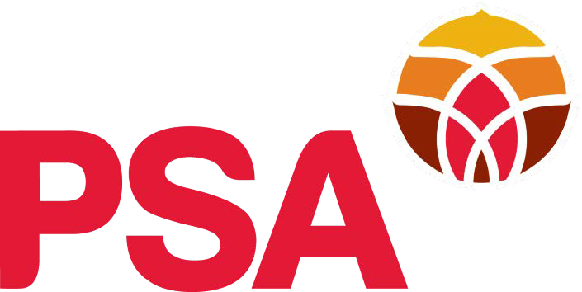
MAKE A “REMARKABLE DIFFERENCE” – JOIN THE FIGHT FOR EQUAL PAY

The Public Service Association | Te Pūkenga Here Tikanga Mahi has a proud history of advocating for equal pay. Since the first year of the PSA in 1913, we’ve been striving to address pay and employment inequities experienced by women.

- 2017 - A $2.2 billion care and support settlement raised wages for 55,000 workers in this sector
- June 2018 - Following agreement with unions including the PSA, the Government extended the 2017 care and support workers’ pay equity settlement to include mental health and addiction support workers. The agreement gave a pay rise to 5000 workers in the sector.
- September 2018 - The PSA and Oranga Tamariki agreed on a pay equity settlement that
achieved a 30% average lift in the salaries of 1300 social workers over 2018-2019. The settlement recognised the historic and ongoing gender-based undervaluation of the social work profession.
- February 2019 - PSA members appeared before the Education and Workforce Select Committee to make the case for strengthening equal pay legislation where they spoke about the impact of being undervalued for working in female dominated occupations. PSA member Judy Robb said the care and support workers’ settlement had made a “remarkable difference”, enabling her to give up one of her two jobs. New legislation was achieved in 2020.
- April 2019 - A petition supporting an equal pay claim for underpaid DHB administration workers was presented to parliament with more than 12,500 signatures. This raised awareness of the vital role administrative workers play in keeping the health system running smoothly. The PSA and DHBs have completed a report on the undervaluation of these workers. Member voted on an interim settlement at the end of 2020.
- 2020/2021 - The PSA are now assessing the work of Mental Health and Public Health Nursing, and Allied Public Health and Technical as part of our equal pay claims with district health boards.
- 2021 - Te Rūnanga on Ngā Toa Āwhina are continuing their work on the Mana Wahine claim with the Waitangi Tribunal. The claim seeks to highlight inequities that have disadvantaged generations of wāhine Māori in the workplace.
- 2021 - Pasefika women suffer the largest pay gap in the public sector, and our Pasefika Network are developing Pasefika pay gap principles to help tackle the issue. Research is also underway into the implementation of EEO policies by agencies with large Pasefika workforces.
- 2021 – In 2019 the PSA raised pay equity claims for library assistants in councils; admin clerical, support workers and social workers in our CPS sector; and admin clerical in public service/kainga Ora and ACC. All of these claims are working through a joint work assessment process.
- To find out more visit www.psa.org.nz/equalpay

PSA President Benedict Ferguson says equal pay has long been one of the union’s key goals and we will continue to support workers as they fight for pay rates that reflect the challenging nature of their jobs.

SO SIGN UP TO BE AN EQUAL PAY ADVOCATE AND HELP IMPROVE THE LIVES OF WOMEN

ACROSS OUR UNION!

Sign up to become a PSA Equal Pay Advocate

Equal Pay Advocates are PSA members (male, female, and gender diverse) who are the
champions of pay equity in big and little ways in their individual workplaces and homes. Several of our sister unions have similar groups of members championing equal pay in their workplaces. Our combined efforts can get the whole country behind us and achieve Worth 100% equal pay in the next few years.

As an Equal Pay Advocate you will:
- add your voice to PSA members’ fight for equal pay – Worth 100%
- talk to your workmates and ask them to join the union – the more people who join the union the sooner we will win equal pay
- put up Worth 100% posters, hand out badges, leaflets and stickers
- pass on updates about the Worth 100% campaign to your fellow workers and keep them in the loop
- make your views known to politicians by talking to the MP in your local area – give them the relevant Worth 100% leaflets and explain how the pay gap affects you and your family
- talk with your union delegates and organiser about planning pay equity activities for your area
- attend events related to pay equity and take others along to them

Please add your name to the register of Equal Pay Advocates. You will automatically receive monthly updates about the PSA Equal Pay Campaign – Worth 100%

Full name: Email address
Return to Janine Bridgeman at Janine.Bridgeman@psa.org.nz
OR Mail to PSA PO Box 3817, Wellington 6140

